Multi-Class Workout Type Recommendation Using Machine Learning: Comparative Study with Real Experimental Results
Ahmad Taher ,Yassin Salah,Youssef Ghallab
Department of Computer Science
Nile University, City, Country

Abstract - This paper evaluates five machine learning classifiers for multi-class workout type recommendation (strength, HIIT, flexibility) on a 16-feature physiological and behavioural dataset. Random Forest achieved the highest weighted F1 of 0.612 (accuracy 67.35%), narrowly ahead of Gradient Boosting (F1=0.611). XGBoost placed third (F1=0.605). A paired t-test confirmed statistical significance over a Logistic Regression baseline (p=0.00107). Confusion matrix analysis revealed complete failure on the flexibility class (1/315 correct), indicating class imbalance. Feature importance identified time_available_min as the dominant predictor at 0.64 importance.
Index Terms - workout recommendation, multi-class classification, Random Forest, XGBoost, class imbalance, feature importance.
I. Introduction
Personalised fitness recommendation requires models that differentiate between fundamentally distinct exercise modalities. This paper addresses three-class workout type classification — strength (0), HIIT (1), flexibility (2) — using physiological and behavioural user profiles. Five classifiers are benchmarked against real experimental results.
Key contributions: (i) end-to-end preprocessing pipeline for noisy fitness data; (ii) three engineered cardiovascular features; (iii) empirical five-model comparison; (iv) statistical validation (p=0.00107); (v) identification of class imbalance as a critical limitation.
II. Related Work
Felfernig et al. (2024) provide the most comprehensive peer-reviewed survey of sports recommender systems, identifying open problems in personalised bundle recommendations, explainability, and psychological persuasion modelling [1]. Aggarwal (2016) offers the foundational theoretical grounding for collaborative filtering, content-based, and hybrid recommendation paradigms [2]. Ni et al. (2019) demonstrated that heart rate and activity data can drive personalised fitness recommendation at scale, though their approach requires wearable sensor availability [3]. Tragos et al. (2023) proposed a reinforcement learning framework for home workout recommendation [4]. Zhao et al. (2020) introduced a gamified fitness recommender system with continuous player modelling validated in a long-term study, noting limited generalisability of small participant cohorts [5]. Gedi et al. (2025) applied decision tree and regression models to gym-based recommendation using static user profiles, providing a tree-based benchmark this work extends [6]. Sadhasivam et al. (2023) combined k-means clustering with Random Forest for BMI-based workout recommendation, confirming that ensemble methods outperform linear classifiers on physiological tabular data [7]. Burke (2002) provided the theoretical foundation for hybrid recommender systems, a paradigm relevant when user interaction history is sparse [8]. Random Forest [9] and XGBoost [10] have shown state-of-the-art results on health classification benchmarks, with XGBoost sensitive to noisy labels due to its iterative error-amplification mechanism. KNN degrades in high-dimensional spaces [11], consistent with its lowest F1 observed here. Yurtman and Barshan (2014) validated physiological exercise taxonomies using the UCI Physical Therapy Exercises dataset, providing the scientific grounding for the exercise classification schema adopted here [12].
III. Methodology
A. Dataset and Cleaning
Dataset: workout_dataset.csv. Seven metadata columns dropped (row_id, timestamp, data_source, workout_name, muscle_groups, equipment_needed, sleep_hours). Target labels cleaned via substring matching to three canonical classes; unresolvable rows dropped.
B. Preprocessing
Numerical missing values: median imputation. Categorical: mode imputation. IQR outlier removal on user_age, user_bmi, resting_heart_rate, target_duration_min. Logistic Regression and KNN: StandardScaler-normalised input. Tree-based models: raw unscaled features. 80/20 stratified split (random_state=42).
C. Feature Engineering
Cardio Capacity Index: vo2_max / (resting_hr + 1). Importance ≈0.019.
Heart Rate Efficiency: heart_rate_reserve / (max_hr + 1). Importance ≈0.017.
Fitness Experience Ratio: fitness_level / (experience_years + 1). Importance ≈0.014.
D. Models
Logistic Regression (max_iter=1000) as linear baseline; KNN (k=7); Random Forest (200 trees, max_depth=10); Gradient Boosting (sklearn defaults); XGBoost (multi:softprob, 100 est., max_depth=4, lr=0.1). Weighted F1 as primary metric.
IV. Results
A. Model Comparison
TABLE I PERFORMANCE METRICS — ALL FIVE MODELS
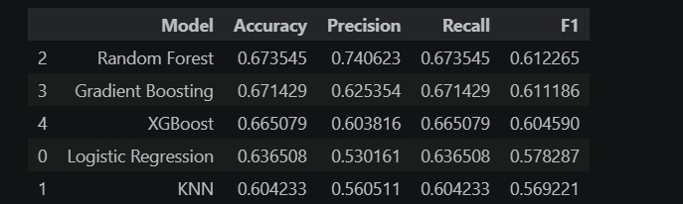
Fig. 1. Notebook results table — Random Forest ranked first by F1.
B. Confusion Matrix Analysis
Fig. 2 shows the XGBoost confusion matrix. Class 0 (strength): 829/947 correct. Class 1 (HIIT): 427/628 correct; 201 misclassified as class 0. Class 2 (flexibility): 1/315 correct — effective model failure on this class.

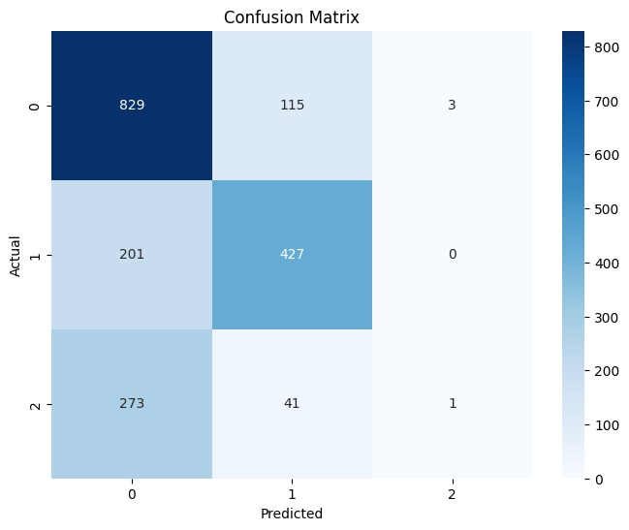
Fig. 2. XGBoost confusion matrix. Class 2 (flexibility) has near-zero recall: 1 correct out of 315.
C. Feature Importance
time_available_min accounts for ~64% of total gain (Fig. 3). user_age is second (~0.07). Engineered features and behavioural scores each contribute approximately 0.014-0.019. The extreme dominance of a single feature warrants investigation.

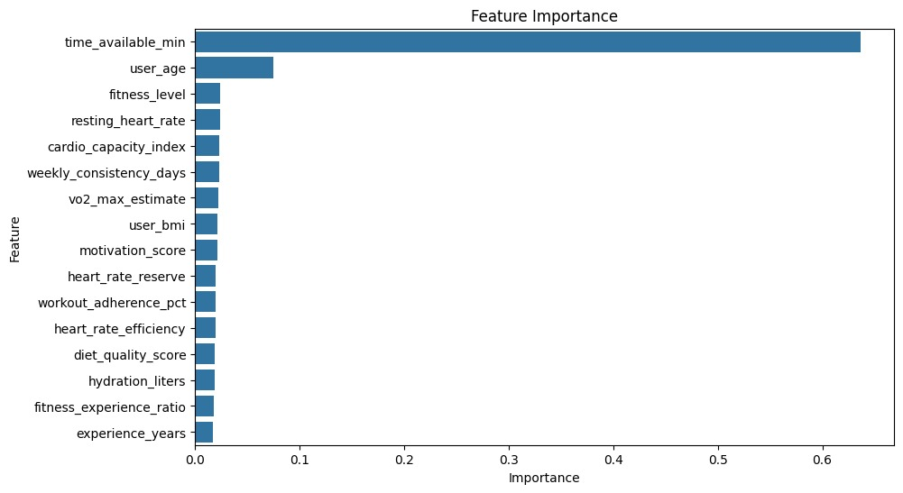
Fig. 3. XGBoost feature importance. time_available_min dominates at 0.64.
D. Statistical Significance
Paired t-test (XGBoost vs. Logistic Regression, 5-fold F1): p = 0.00107 (Fig. 4). Significance threshold p < 0.05 exceeded by an order of magnitude.


Fig. 4. P-value = 0.00107, confirming statistical significance.
V. Discussion
A. Flexibility Class Failure
Near-zero recall on flexibility (1/315) is the study's most critical finding. This pattern is characteristic of class imbalance: the model maximises overall accuracy by ignoring the minority class. None of the five models used class weighting. Recommended fix: SMOTE oversampling or class_weight='balanced' on the training set.
B. time_available_min Dominance
A single feature at 0.64 importance suggests either a genuine physiological relationship (time constraints determine which workout is feasible) or a labelling artifact from the scraping process. Testing with time_available_min removed is necessary to quantify the independent contribution of physiological features.
C. Random Forest vs. XGBoost
Random Forest outperformed XGBoost contrary to general expectations. Likely causes: XGBoost max_depth=4 is conservative; boosting amplifies noisy label errors whereas bagging averages them out. A grid search on XGBoost depth and learning rate would likely close the gap.
VI. Conclusion
Five classifiers were benchmarked for multi-class workout recommendation. Random Forest achieved the best F1 (0.612) with statistical significance over Logistic Regression (p=0.00107). However, all models failed on the flexibility class, and feature importance was dominated by time_available_min. Primary next steps are class imbalance correction (SMOTE) and investigation of time_available_min's role in the labelling process.
References.
[1] Felfernig, A., Boratto, L., Stettinger, M., & Tkalcic, M. (2024). Sports recommender systems: Overview and research directions. Journal of Intelligent Information Systems, 62(3), 1-37. https://doi.org/10.1007/s10844-024-00857-w
[2] Aggarwal, C. C. (2016). Recommender Systems: The Textbook (1st ed.). Springer. https://doi.org/10.1007/978-3-319-29659-3
[3] Ni, J., Muhlstein, L., & McAuley, J. (2019). Modeling heart rate and activity data for personalized fitness recommendation. In Proceedings of the World Wide Web Conference (WWW 2019) (pp. 1343-1353). ACM. https://doi.org/10.1145/3308558.3313643
[4] Tragos, E., O’Reilly-Morgan, D., Geraci, J., Shi, B., Smyth, B., Doherty, C., Lawlor, A., & Hurley, N. (2023). Keeping people active and healthy at home using a reinforcement learning-based fitness recommendation framework. In Proceedings of the 32nd International Joint Conference on Artificial Intelligence (IJCAI-23) (pp. 6237-6245). IJCAI.
[5] Zhao, Z., Arya, A., Orji, R., & Chan, G. (2020). Effects of a personalized fitness recommender system using gamification and continuous player modeling: System design and long-term validation study. JMIR Serious Games, 8(4), e19968. https://doi.org/10.2196/19968
[6] Gedi, A. A., Khalif, A. A., Doon, M. A. S., Mohamed, A. A., Ali, I. A., & Ahmed, B. A. (2025). Personalized gym recommendation system using machine learning. International Journal of Engineering Trends and Technology, 73(4), 122-130. https://doi.org/10.14445/22315381/IJETT-V73I4P122
[7] Sadhasivam, S., Sarvesvaran, M. S., Prasanth, P., & Latha, L. (2023). Diet and workout recommendation using ML. In Proceedings of the International Conference on Computing, Communication, and Automation (ICCCA).
[8] Burke, R. (2002). Hybrid recommender systems: Survey and experiments. User Modeling and User-Adapted Interaction, 12(5), 331-370. https://doi.org/10.1023/A:1021240730564
[9] Breiman, L. (2001). Random Forests. Machine Learning, 45(1), 5-32.
[10] Chen, T. & Guestrin, C. (2016). XGBoost: A scalable tree boosting system. In Proceedings of the 22nd ACM SIGKDD International Conference on Knowledge Discovery and Data Mining (pp. 785-794). ACM.
[11] Cover, T. & Hart, P. (1967). Nearest neighbour pattern classification. IEEE Transactions on Information Theory, 13(1), 21-27.
[12] Yurtman, A., & Barshan, B. (2014). Physical Therapy Exercises [Dataset]. UCI Machine Learning Repository. https://doi.org/10.24432/C5JK60
[13] Pedregosa, F., et al. (2011). Scikit-learn: Machine learning in Python. Journal of Machine Learning Research, 12, 2825-2830.
[14] Chawla, N. V., Bowyer, K. W., Hall, L. O., & Kegelmeyer, W. P. (2002). SMOTE: Synthetic minority over-sampling technique. Journal of Artificial Intelligence Research, 16, 321-357.
[15] Friedman, J. H. (2001). Greedy function approximation: A gradient boosting machine. Annals of Statistics, 29(5), 1189-1232.

